|  |  |
| --- | --- |
| Assignment Date | 25 September 2022 |
| Student Name | SAKTHIVEL.K.R |
| Student Roll Number | 960519205013 |
| Maximum Marks | 2 Marks |

# Challenge:-

* Upload the dataset to Cognos Analytics, prepare the data, explore and Create

Interactive Dashboard.

# Solution:

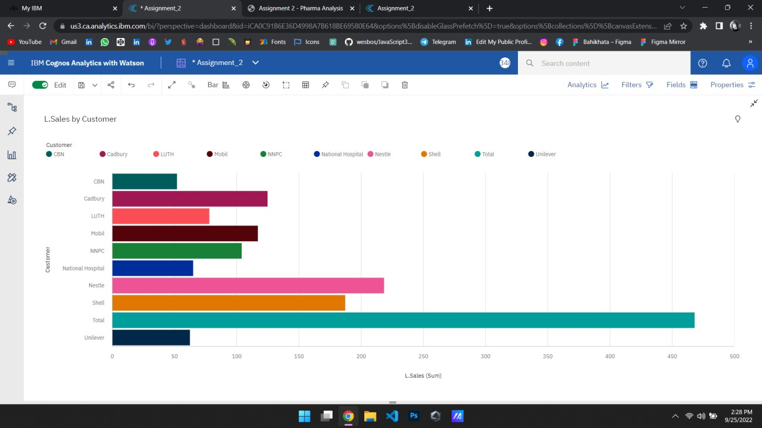



Task 1: Sales by Customer:



Task 2: Sales by Location:

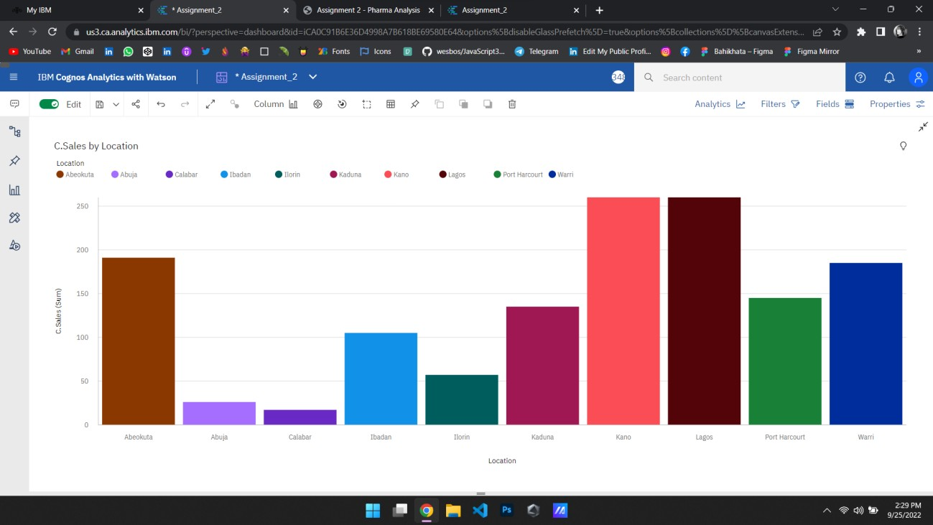

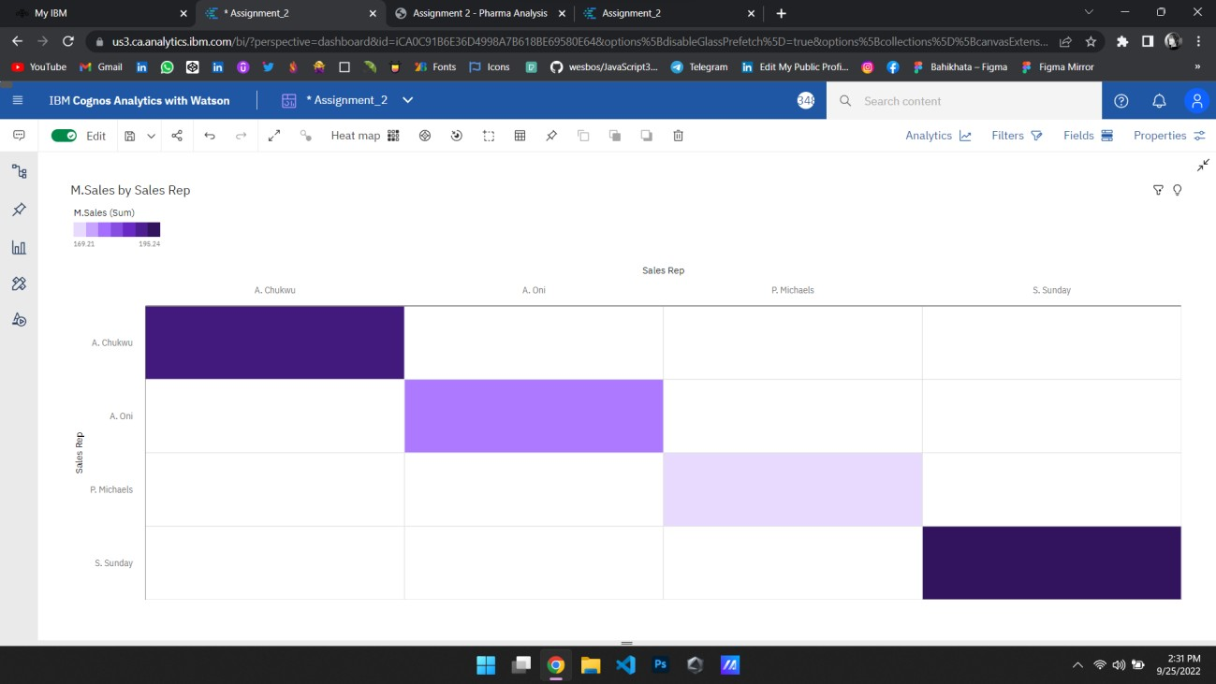



Task 3: Sales by Sales Representative:



Task 4: Received Inventory From Supplier:

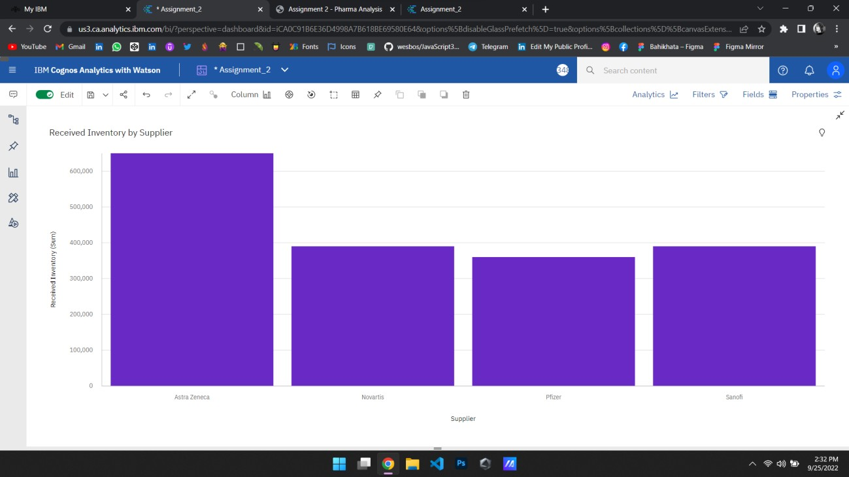

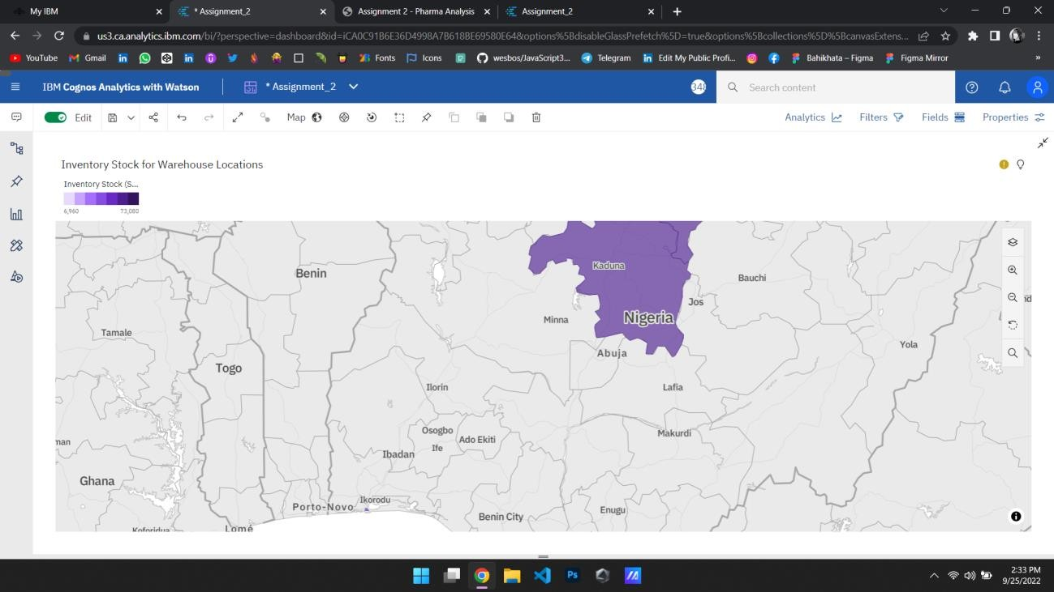



Task 5: Inventory Stock for Warehouse Locations:



Task 6: Sales Trend:

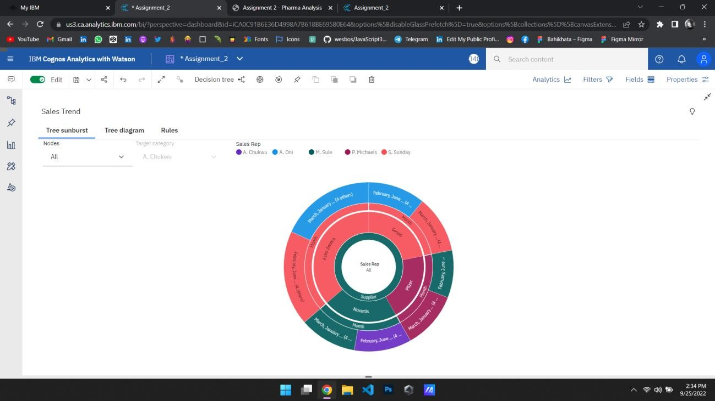

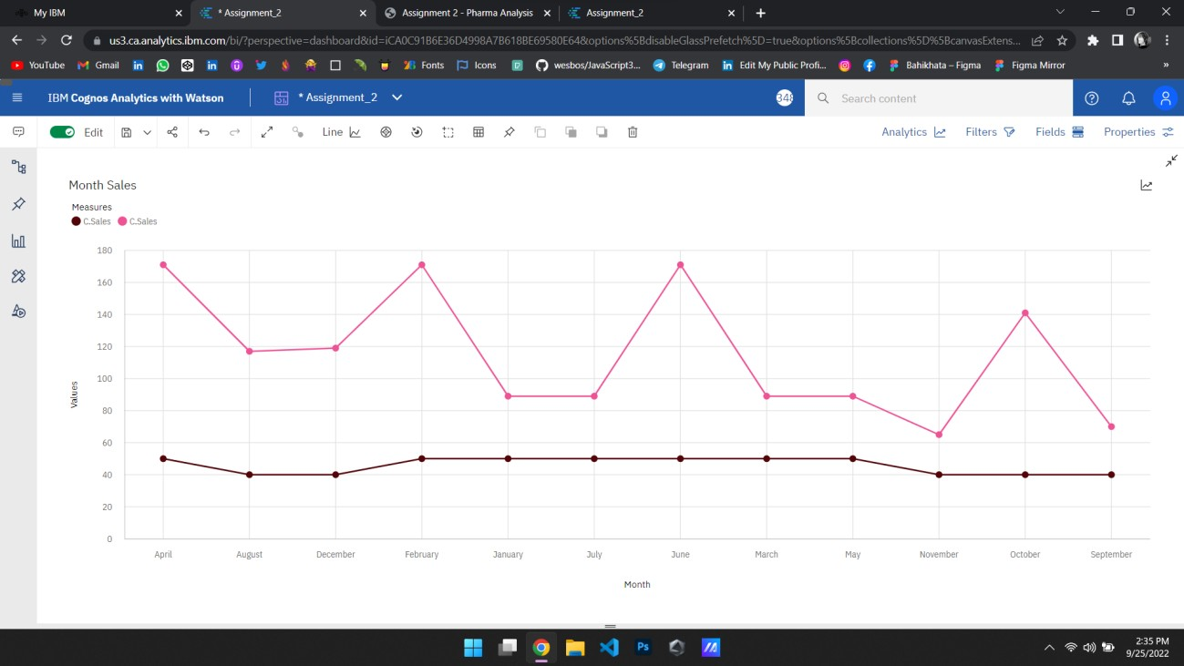



Task 7: Monthly Sales:



Task 8: Actual and Received Inventory by Month:

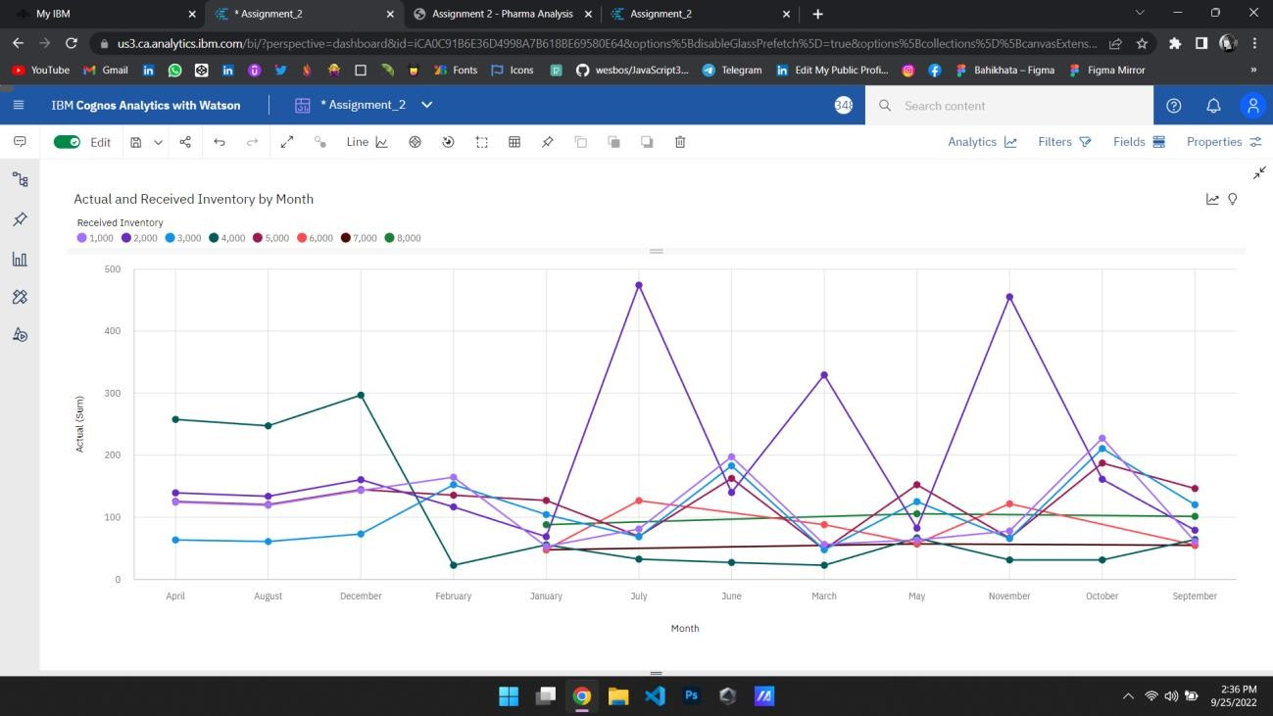



Reference:

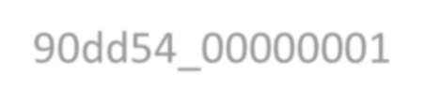

[https://us3.ca.analytics.ibm.com/bi/?perspective=dashboard&](https://us3.ca.analytics.ibm.com/bi/?perspective=dashboard&pathRef=.my_folders%2Fdata%2Bdashboard%2FAssignment_2&action=view&mode=dashboard&subView=model000001837390dd54_00000001)

[pathRef=.my_folders%2Fdata%2Bdashboard%2FAssignment_2](https://us3.ca.analytics.ibm.com/bi/?perspective=dashboard&pathRef=.my_folders%2Fdata%2Bdashboard%2FAssignment_2&action=view&mode=dashboard&subView=model000001837390dd54_00000001) [&action=view&mode=dashboard&subView=model0000018373](https://us3.ca.analytics.ibm.com/bi/?perspective=dashboard&pathRef=.my_folders%2Fdata%2Bdashboard%2FAssignment_2&action=view&mode=dashboard&subView=model000001837390dd54_00000001) [90dd54_00000001](https://us3.ca.analytics.ibm.com/bi/?perspective=dashboard&pathRef=.my_folders%2Fdata%2Bdashboard%2FAssignment_2&action=view&mode=dashboard&subView=model000001837390dd54_00000001)